 CHEMICAL ENGINEERING TRANSACTIONS  VOL. xxx, 2025 | A publication of  
The Italian Association
of Chemical Engineering
Online at www.cetjournal.it

Guest Editors: Fabrizio Bezzo, Flavio Manenti, Gabriele Pannocchia, Almerinda di Benedetto
Copyright © 2025, AIDIC Servizi S.r.l.
ISBN 979-12-81206-17-5; ISSN 2283-9216

Thermochemical Valorization of Açaí (Euterpe oleracea) Seeds: A Study Using Gibbs Energy Minimization and Entropy Maximization Methods
Yan Caio Morais da Costaª, Ana Carolina Portela Pessoa Coelhoª, Julles Mitoura dos Santos Júnior^{b}, Annamaria Dória Souza Vidottiª, Antonio Carlos Daltro de Freitas^{b}, Reginaldo Guirardello^{a*}
ªFederal University of Maranhão: Chemical Engineering Department, São Luís - MA, Brazil
^{b}School of Chemical Engineering, University of Campinas (UNICAMP), Campinas - SP, Brazil
guira@feq.unicamp.br
The use of biomass as a primary source for production of hydrogen (H₂) and synthesis gas (syngas) has gained significant attention due to its potential to diversify the global energy matrix. An example of biomass particularly relevant to Brazil is Euterpe oleracea, commonly known as açaí. The seeds of this fruit account for approximately 70% of its mass and are a major by-product of açaí pulp production. In this work, the thermodynamic analysis was performed using Gibbs energy minimization (minG) and entropy maximization (maxS) models in order to study the thermochemical characterization of açaí seeds. The optimization problems were formulated as nonlinear programming problems and solved using GAMS and TeS software’s. The reactions studied included Pyrolysis (PR), Autothermal Reforming (ATR), Steam Reforming (SR), and Supercritical Water Gasification (SCWG). The results showed that thermochemical valorization pathways are effective for generating H₂ and syngas from açaí seeds. Among the various processes, ATR demonstrated promising results, with good productivity of H₂ and syngas and nearly autothermal behavior, while SCWG achieved the high H₂ production, showing favorable energetic and reactional characteristics. Açaí seeds has proven to be a promising alternative for energy production through thermochemical processing, offering strong potential for generation of clean and renewable energy, particularly in Brazil's açaí-producing regions.
  - Introduction
According to 2023 data from the Brazilian Institute of Geography and Statistics (IBGE), Brazil is the world’s largest producer of açaí, with the highest levels of production concentrated in the North and Northeast regions. By 2021, Maranhão had ascended to third place in national açaí production, harvesting over 5,000 tons of fruit, underscoring its importance in the country’s açaí industry. Açaí production generates substantial waste, primarily in the form of seeds, which constitute about 70% of the fruit's total mass (Ribeiro et al., 2018). Given the large volume of this by-product, exploring methods to add value to açaí seed waste presents a promising area for research.
Thermochemical processes are vital in the search for clean, renewable energy sources and can play a key role in the thermochemical recovery of various agro-industrial by-products. These processes facilitate the conversion of residual biomass, such as açaí seeds, into hydrogen—a highly efficient, low-carbon, and versatile fuel. Optimizing these processes through simulation models is essential for scaling them commercially and supporting the transition to a more sustainable energy system (Rahimi et al., 2022).
Among thermochemical processes, pyrolysis (PR), steam reforming (SR), autothermal reforming (ATR), and supercritical water gasification (SCWG) are promising alternatives for the thermochemical valorization of carbon-rich biomasses like açaí seeds (Zhang et al., 2025).
This study seeks to apply optimization techniques to calculate combined chemical and phase equilibrium in systems relevant to the thermochemical valorization of açaí seeds. The systems were analyzed using Gibbs energy minimization (at constant pressure and temperature) and entropy maximization (at constant pressure and enthalpy). Specifically, the study focuses on the thermodynamic characterization of PR, SR, ATR, and SCWG processes. The findings of this work will contribute to a broader understanding of the thermodynamic characteristics of these processes involved in valorizing residual biomass in the açaí production chain, thereby facilitating more targeted research on producing energy vectors from this underutilized raw material in Brazil.
  - Methodology
    - Formulation as a Gibbs energy minimization (minG) model
The equilibrium composition of a system with multiple components and phases, under conditions of constant pressure and temperature, can be determined by directly minimizing the Gibbs free energy of the system, taking into account the number of moles of each component in each phase. Equation 1 illustrates this approach for a system where gas, liquid, and solid phases may form (Freitas and Guirardello, 2014).
$$\min{G}=\sum_{i=1}^{NC}{n_{i}^{g}μ_{i}^{g}}+\sum_{i=1}^{NC}{n_{i}^{l}μ_{i}^{l}}+\sum_{i=1}^{NC}{n_{i}^{s}μ_{i}^{s}}$$ | (1)
where $n_{i}^{k}$ is the number of moles of component i in phase k, and $μ_{i}^{k}$ is the chemical potential of component i in phase k. The restrictions for the model are found in the non-negativity of the number of moles of each component in each phase and the balance of moles obtained by the atomic balance for reactive systems (Equation 2).
$$\sum_{i=1}^{NC}{a_{mi}\left(n_{i}^{g}+n_{i}^{l}+n_{i}^{s}\right)=}\sum_{i=1}^{NC}{a_{mi}n_{i}^{0}}, m=1,…,NE, { n}_{i}^{g},n_{i}^{l},n_{i}^{s}≥0$$ | (2)
where a_{mi} is the number of atoms of element i in component m and NE is the number of elements. The minG was calculated considering that the components were only on gaseous phase and there was only coke formation (represent as pure carbon, C_{(s)}) in solid phase. These considerations were used in previous research with good results (Dos Santos et al., 2021). Equation 3 represents the Gibbs energy equation with these considerations.
$$G=\sum_{i=1}^{NC}{n_{i}^{g}\left(μ_{i}^{g}+RT\left(\ln{P}+\ln{y_{i}}+\ln{{\hat{ϕ}}_{i}}\right)\right)}+n_{C_{(s)}}μ_{C_{(s)}}$$ | (3)
Here, P represents pressure, T is temperature, R is the universal gas constant, $y_{i}$ is the mole fraction of gas component i, and ${\hat{ϕ}}_{i}$​ is the fugacity coefficient of component i. The minG model allows for the analysis of the reaction system under isothermal and isobaric conditions, meaning the operating temperature remains constant throughout the process simulation.
    - Formulation as an entropy maximization (maxS) model
Thermodynamic equilibrium can also be studied by maximizing the entropy of the system under conditions of constant pressure and enthalpy, as presented in Equation 4, satisfying the atom balance Eq. (2) and $n_{i}^{k}≥0$.
$$\max{S}=\sum_{i=1}^{NC}{n_{i}^{g}S_{i}^{g}}+\sum_{i=1}^{NC}{n_{i}^{l}S_{i}^{l}}+\sum_{i=1}^{NC}{n_{i}^{s}S_{i}^{s}}$$ | (4)
where $S_{i}^{k}$ represent the entropy of component i in phase k. The restrictions mentioned above for non-negativity of number of moles and atom balance (Equation 2) are also necessary for the maxS model, with the addition of conservation of enthalpy and non-negativity of absolute temperature, represented by Equation 5.
$$\sum_{I=1}^{NC}{\left(n_{i}^{g}H_{i}^{g}+n_{i}^{l}H_{i}^{l}+n_{i}^{s}H_{i}^{s}\right)}=\sum_{i=1}^{NC}{n_{i}^{0}H_{i}^{0}}=H^{0} , T≥0$$ | (5)
Non-ideality in both thermodynamic models is accounted for by the fugacity coefficient, which is calculated using truncated virial equation of state, considering the second virial coefficient. The expression for the second virial coefficient is based on the correlation proposed by Pitzer (Pitzer et al., 1955), modified by Tsonopoulos (1974), as shown in Equation 6. This combination of thermodynamic formulations and equations of state has been successfully applied to reforming systems, as demonstrated in the work of Freitas and Guirardello (2014) and in Maia et al. (2024).
$$\ln{{\hat{ϕ}}_{i}}=\left[2\sum_{j}^{m}{y_{j}B_{ij}-B}\right]∙\frac{P}{RT}$$ | (6)
where $B$ is the mixture second virial coefficient and $B_{ij}$ is the second virial coefficient for the $ij$ pair. The maxS model, on the other hand, incorporates temperature variation in its thermodynamic formulation, effectively representing an adiabatic process. This model provides a more accurate behavior of the studied systems.
    - Thermodynamic analysis – computational strategy
The models used in this study perform simultaneous chemical and phase equilibrium calculations, formulated as nonlinear programming problems. For the simulations, the General Algebraic Modeling System (GAMS)® 23.9.5 software was employed, with the CONOPT3 solver. This solver utilizes the generalized reduced gradient (GRG) method, a robust algorithm for solving nonlinear programming problems, such as the minG and maxS thermodynamic models used in this work. Additionally, the free software TeS (Thermodynamic Equilibrium Simulation) was used for the thermodynamic characterization of açaí seed reforming processes.
This combination of software and solver has been successfully applied in previous studies, delivering excellent results, particularly in comparison with experimental data (Gomes et al., 2022). In the simulations, açaí seeds were represented as a pseudocomponent, with their chemical composition determined through elemental analysis of seeds sourced from pulp production residue at a public market in São Luís-MA, Brazil. The resulting chemical formula was C_{3.90}H_{5.87}O_{2.74}N_{0.06}. A total of 13 compounds were considered in the simulations, including hydrogen (H₂), methane (CH₄), water (H₂O), carbon monoxide (CO), carbon dioxide (CO₂), oxygen (O₂), nitrogen (N₂), ammonia (NH₃), nitric oxide (NO), nitrogen dioxide (NO₂), methanol (CH₃OH), ethane (C₂H₆), and ethylene (C₂H₄). All thermodynamic properties for these compounds were sourced from the literature (Polling et al., 2001).
ATR, PR, SR, and SCWG reactions were thermodynamically characterized for temperature ranges between 730 and 1130 K, and pressures between 1 and 20 bar for SR, PR, and ATR reactions, and between 220 and 260 bar for SCWG. The feed composition varied from 5 to 23 wt% for biomass, oxidizing agents: O₂ and H₂O (in equimolar amounts) for ATR, pure H₂O for SCWG, and no oxidant for PR. The four reaction routes (PR, SR, ATR, and SCWG) were first thermodynamically evaluated in GAMS to identify those that showed the highest hydrogen gas productivity. Subsequently, the two reaction paths with the highest gas production were further detailed in TeS software, with over 2,000 simulations carried out for each reaction. These simulations aimed to determine the characteristic effects of each reaction and to explore the combined effects of the operational variables within each thermochemical route.
  - Results and discussion
The results obtained for the maximum H₂ and CH₄ production (determined from minG or maxS simulations) and the equilibrium temperature (starting from an initial temperature of 900 K) using GAMS software are presented in Table 1.
Table 1. Maximum H₂ production, maximum CH₄ production and equilibrium temperature for ATR, SR, PR and SCWG of açaí seeds.
Reforming type | Maximum H₂ production (mol%)¹ | Maximum CH₄ production (mol%)¹ | Equilibrium temperature² (K)
ATR | 39.2, maxS at 1138.7 K; 1 bar | 43.1, minG at 730 K; 1 bar | 1138.7
PR | 29.2, minG at 950 K; 1 bar | 39.8, minG at 730 K; 1 bar | 620.3
SR | 37.4, minG at 1000 K; 1 bar | 55.4, min G at 730 K; 1 bar | 384.5
SCWG | 38.7, minG at 1130 K; 220 bar | 48.9, minG at 730 K; 230 bar | 892.4
¹considering both simulations maxS and minG, the indication next to the number represents the reaction condition where maximum H₂ production was reached, the value besides represents the temperature of the process where this production was reached. ²For all thermochemical processes tested the initial temperature was fixed at 900K (intermediate value within the tested conditions).

The highest CH₄ and H₂ production were observed at lower pressures: 1 atm for PR, SR, and ATR, and 220 bar for SCWG. According to Table 1, SCWG and ATR reactions achieved the highest H₂ molar productivity, primarily due to the high-water content in both processes, which promotes the water-gas shift reaction and enhances H₂ output (Chen and Chen, 2020). Similar findings were reported by Freitas and Guirardello (2014) and Santos-Júnior et al. (2024) in studies of thermochemical conversion pathways and black liquor gasification. However, this study distinguishes itself due to the greater complexity of the açaí seed biomass, which includes nitrogen and a higher C/H molar ratio, leading to more challenging operational conditions due to increased chemical reactions. The higher C/H ratio results in a larger proportion of carbonaceous compounds in the output compared to other biomass sources.
In terms of thermal behavior, the ATR process showed maximum hydrogen production at 1138.7 K, achieved using the maxS method (non-isothermal operation). This indicates that the ATR process for açaí seeds is slightly exothermic, a trend that supports H₂ production in the ATR reactive system (Gomes et al., 2022). On the other hand, SR, PR, and SCWG reactions showed endothermic behavior, with the SR reaction being the most endothermic among them (Brito et al., 2023). Maximum H₂ production for PR, SR, and SCWG occurred during the minG simulations. This behavior is expected, as endothermic processes tend to be more productive under isothermal conditions, such as those simulated by the minG model.
Maximum CH₄ production occurred during minG simulations at lower temperatures, consistent with expectations, as higher temperatures are typically associated with CH₄ decomposition into H₂ and CO_{x} gases. The primary nitrogen derivative across all simulations was pure N₂ (about 97%), with small amounts of NO and NO₂ (less than 10⁻⁵ mol) detected in the ATR reaction, possibly due to higher oxidizing agents in the feed. NH₃ was also produced in small quantities (less than 10⁻⁶ mol) in all simulated processes.
The highest H₂ production was observed in the minG simulations for SCWG, while the ATR reaction showed the most interesting operational behavior in maxS simulations. These characteristics made SCWG and ATR the most intriguing processes, prompting further analysis with TeS software. Figure 1 presents the results: Panel (a) shows the Spearman correlation for SCWG (minG model), and panel (b) shows the ATR process (maxS model).
The results from Figure 1 indicate that pressure had a secondary influence on SCWG for açaí seeds, aligning with findings by Maia et al. (2024) for lignocellulosic biomass. Temperature significantly influenced CO and H₂ production, which is linked to the water-gas shift reaction. CH₄ exhibited a strong negative correlation with temperature, suggesting that CH₄ is degraded at higher temperatures, acting as an intermediate in açaí seed biomass decomposition during SCWG. Ammonia formation was favored at lower temperatures, but no significant amounts were observed in the product. The direct relationship between biomass and hydrogen production was of secondary importance, indicating that the primary reaction pathway in SCWG involves intermediate compounds, like findings by Guan et al. (2012) for microalgal biomass decomposition in supercritical water.
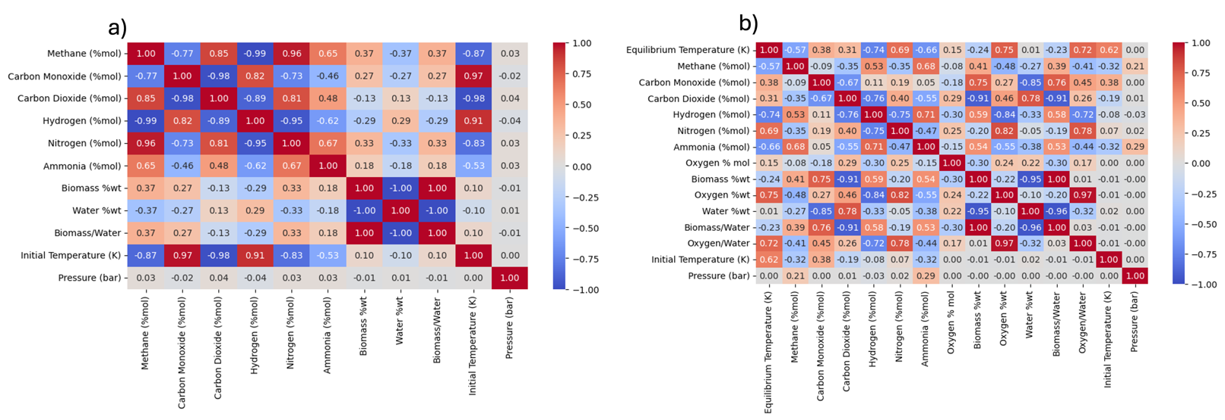
Figure 1. Spearman correlations for SCWG using minG model (a) and ATR using maxS model (b) of açaí seeds.

For the ATR process, shown in Figure 1(b), pressure plays a more significant role than in the SCWG reaction discussed earlier, particularly in the production of NH₃ and CH₄. NH₃, while still a secondary product from the degradation of nitrogen in the biomass, was more favorably produced as operating pressure increased during ATR reaction. The initial operating temperature demonstrated a strong correlation with the equilibrium temperature, indicating that higher initial temperatures lead to higher equilibrium temperatures, as expected. H₂ production was favored at higher equilibrium temperatures, with minimal dependence on operating pressure. Unlike the SCWG process, the amount of biomass in the feed was directly proportional to the amount of H₂ produced in the ATR process, suggesting that different reaction pathways are followed during açaí seed decomposition in SCWG and ATR. To investigate the combined effects of pressure and temperature on H₂ production, Figures 2 (a) and 2 (b) were constructed for the SCWG and ATR processes, respectively, with the biomass input set at 23% by weight. The SCWG process was evaluated using the minG model, while the ATR process was evaluated using the maxS model. From the results of this figure, it is evident that the ATR process produces higher total molar amounts of H₂ compared to the SCWG process.
The behavior of the main gaseous products (CH₄, CO, CO₂, H₂, and N₂) is shown in Figures 2 (c) and 2 (d) for the SCWG and ATR processes of açaí seeds, respectively. Figure 2 (d) also includes the equilibrium temperature of the system (available only for the maxS model, which is non-isothermic).
Upon evaluating the results in Figures 2 (c) and 2 (d), it is clear that high molar fractions of H₂ gas are produced at higher temperatures for both processes (SCWG and ATR). An interesting observation is that the ATR process operates at high temperatures, even when the initial operating temperature is lower. For example, at an initial temperature of 750 K, the equilibrium temperature (which represents the operating temperature of the system) reached 1218 K, highlighting the highly exothermic nature of the ATR process (Zhao et al., 2015). Another noteworthy trend is that the ATR process consistently produces a high molar fraction of H₂, remaining above 50% under all tested conditions.

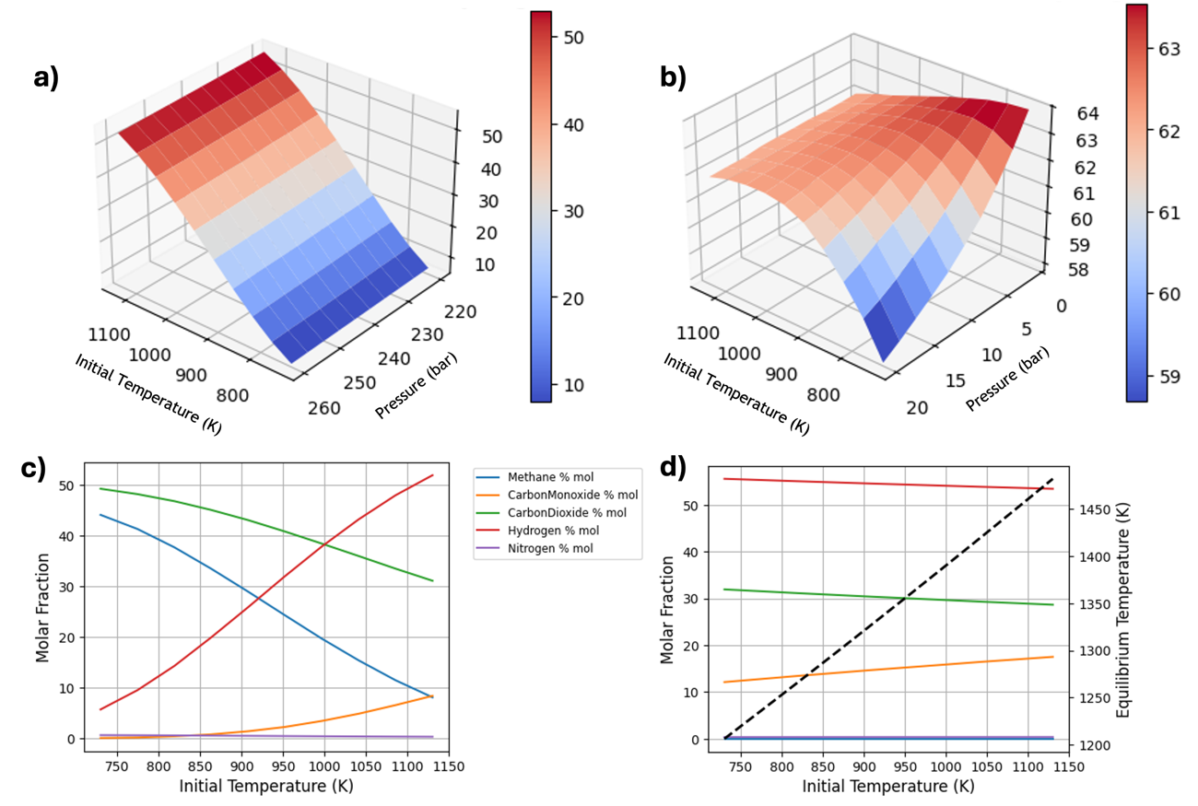
Figure 2. Response surfaces for combined effects of temperature and pressure, behavior of molar compositions and equilibrium temperature (---) resulting from the verified processes (a: SCWG for biomass equal to 23 %wt; b: ATR for biomass equal to 23 %wt; c: SCWG at 220 bar and biomass equal to 23 %wt; d: ATR at 1 bar and biomass equal to 23 %wt).

Upon further evaluation of the results presented in Figures 2(c) and 2(d), it is evident that in both cases, H₂ was the primary product formed at high temperatures. In the isothermal SCWG process (Figure 2(c)), significant production of CO₂ and CH₄ was observed, with these being the predominant compounds in the reaction system at lower temperatures. Under the tested SCWG conditions, CO production was consistently low, never exceeding 10 mol%. The formation of products showed a strong dependence on the process temperature. Similar findings for the SCWG process are reported by Gomes et al. (2022) in their study on glycerol SCWG. In contrast, the adiabatic ATR process (Figure 2(d)) displayed less sensitivity to the initial operating temperature. This was expected, as the exothermic nature of the ATR process ensures equilibrium temperatures consistently exceeding 1100 K. Throughout the ATR process, H₂ remained the dominant product, followed by CO₂ and CO. CH₄ was always present in low concentrations (less than 2% molar), indicating its rapid consumption in the system due to the high equilibrium temperatures achieved at ATR process.
  - Conclusions
The methodologies proposed in this study have proven reliable for thermodynamic predictions in the PR, SR, ATR, and SCWG reactive systems using real biomass, represented by açaí seeds in performed simulations. The approaches applied using GAMS demonstrated efficiency and speed, with computational times of less than 5 seconds for all cases analyzed. Longer computational times were observed for systems simulated using the maxS method compared to those using the minG model, due to the higher mathematical complexity of the maxS thermodynamic model, since in this case T is a variable too. The free software TeS was also found to be robust in facilitating thermodynamic analysis of various thermochemical processes, a total of 4,000 simulations were carried out in this software for the ATR and SCWG processes, with a total computational time of approximately 20 minutes. The results indicate that both the SCWG and ATR processes are promising routes for hydrogen production, achieving over 50% of the total molar fraction of H₂ (on a dry basis) at high operating temperatures. The analysis of operational effects and product formation suggested that distinct reaction pathways are followed in each of these thermochemical processes. Açaí seeds have thus emerged as a promising feedstock for energy production through thermochemical processing, with strong potential for clean and renewable energy generation, particularly in Brazil's açaí-producing regions.
Nomenclature
${\hat{ϕ}}_{i}$ – Fugacity coefficient of component i in mixture
$a_{mi}$– Number of atoms of i in component m
$B$ – Second virial coefficient for the mixture
$B_{ij}$ – Second virial coefficient for the $ij$ pair
g – Gas phase
G – Gibbs energy
l – Liquid phase
$H^{0}$ – Total initial enthalpy
$H_{i}^{0}$ – Initial enthalpy of component i
$H_{i}^{k}$– Enthalpy of component i in phase k
NC – Number of components
NE – Number of elements
$n_{i}^{0} –$Initial number of moles
$n_{i}^{k}$ – Number of moles of component i in phase k
$S_{i}^{k}$– Entropy of component i in phase k
$y_{i}$ – Molar fraction of gas phase
P – Pressure
R – Universal gas Constant
s – Solid phase
T – Temperature

$μ_{i}^{k}$ – Chemical potential of component i in phase k

Acknowledgments
We are grateful for the financial support from the National Agency of Petroleum, Natural Gas and Biofuels (ANP) through the ANP Human Resources Training Program for the Oil and Gas Sector (PRH 54.1 - UFMA), CNPq (Conselho Nacional de Desenvolvimento Científico e Tecnológico) and FAPEMA (Fundação de Amparo a Pesquisa e ao Desenvolvimento Científico e Tecnológico do Maranhão).
References
Brito J., Pinto F., Ferreira A., Soria M.A., Madeira L.M., 2023, Steam reforming of biomass gasification gas for hydrogen production: From thermodynamic analysis to experimental validation, Fuel Processing Technology, 250, 107859.
Chen W.H., Chen C.Y., 2020, Water gas shift reaction for hydrogen production and carbon dioxide capture: A review, Applied Energy, 258, 114078.
Freitas A.C.D., Guirardello R., 2014, Comparison of several glycerol reforming methods for hydrogen and syngas production using Gibbs energy minimization, International Journal of Hydrogen Energy, 39, 17969-17984.
Gomes J. G., Mitoura J., Vidotti A.D.S., Freitas A.C.D, Guirardello R., 2022, Analysis of Hydrogen Production from Glycerol Gasification using Supercritical and Subcritical Water. Chemical Engineering Trasactions, 92, 133-139.
Guan Q., Wei C., Savage P.E., 2012, Kinetic model for supercritical water gasification of algae, Phys. Chem. Chem. Phys., 14, 3140-3147.
IBGE, 2023, Açaí Production (cultivation) Instituto Brasileiro de Geografia e Estatística < https://www.ibge.gov.br/explica/producao-agropecuaria/acai-cultivo/br > accessed 11.12.2024.
Pitzer K.S., Lippmann D.Z., Curl R.F., Huggins C.M., Petersen D.E., 1955, The Volumetric and Thermodynamic Properties of Fluids. I. Theoretical Basis and Virial Coefficients J. Am. Chem. Soc., 77, 3433–3440.
Polling, B.E.; Prausnitz, J.M.; O’connell, J.P. Properties of Gases and Liquids; McGraw-Hill Education: New York, NY, USA, 2001.
Rahimi Z., Anand A., Gautam S., 2022, An overview on thermochemical conversion and potential evaluation of biofuels derived from agricultural wastes, Energy Nexus, 7, 100125.
Ribeiro L.A.S., Thim G.P., Alvarez-Mendez M.O., Coutinho A.R., Moraes N.P., Rodrigues L.A., 2018, Preparation, characterization, and application of low-cost açaí seed-based activated carbon for phenol adsorption. International Journal of Environmental Research, 12, 755–764.
Santos-Júnior J.M., Vidotti A.D S., Freitas A.C.D., Guirardello R., 2024, Black Liquor Gasification in Supercritical Water: Thermodynamic Study for Isothermal Systems. Chemical Engineering Transactions, 109, 205-210.
Tsonopoulos C., 1974, An empirical correlation of second virial coefficients, AIChE Journal, 20, 263–272.
Zhang J., Gu J., Shan R., Yuan H., Chen Y., 2025, Advances in thermochemical valorization of biomass towards carbon neutrality, Resources, Conservation and Recycling, 212, 107905.
Zhao H., Guo L., Zou X., 2015, Chemical-looping auto-thermal reforming of biomass using Cu-based oxygen carrier, Applied Energy, 157, 408-415.

